WEB TECHNOLOGY AND MOBLE APPLICATION
WEEK 01
GITHUB LINK: https://github.com/Zaina-Raheen/web-technology-and-mobile-application

PROGRAM 1:
CODE:
<!DOCTYPE html>
<html lang="en">
<head>
<meta charset="UTF-8">
<title>Voting Awareness Portal</title>
<style>
body { font-family: 'Segoe UI', Tahoma, sans-serif; background-color: #f4f7f6; padding: 20px; }
.container { background: white; padding: 30px; border-radius: 8px; box-shadow: 0 4px 15px rgba(0,0,0,0.1); }
h1 { color: #2c3e50; border-bottom: 2px solid #e74c3c; padding-bottom: 10px; }
table { width: 100%; border-collapse: collapse; margin-top: 20px; border: 2px solid #34495e; }
th, td { padding: 12px; text-align: left; border: 1px solid #ddd; }
th { background-color: #34495e; color: white; }
tr:nth-child(even) { background-color: #f2f2f2; }
</style>
</head>
<body>
<div class="container">
<h1>Voter Eligibility & Records</h1>

<h3>General Requirements (Unordered List)</h3>
<ul>
<li>Must be a citizen of the country.</li>
<li>Must be 18 years of age or older.</li>
<li>Must have a valid Government ID.</li>
<li>Must be a resident of the voting district.</li>
</ul>

<h3>Registration Process (Ordered List)</h3>
<ol>
<li>Visit the Online Voting Awareness Portal.</li>
<li>Fill out the Digital Registration Form.</li>
<li>Upload necessary identity documents.</li>
<li>Verify your email and receive your Voter ID.</li>
</ol>

<h3>Sample Voter Records</h3>
<table>
<thead>
<tr>
<th>Record ID</th>
<th>Voter Name</th>
<th>Constituency</th>
<th>Status</th>
</tr>
</thead>
<tbody>
<tr>
<td>V-101</td>
<td>Rahul Sharma</td>
<td>Central District</td>
<td style="color: green; font-weight: bold;">Verified</td>
</tr>
<tr>
<td>V-102</td>
<td>Priya Singh</td>
<td>North Zone</td>
<td style="color: orange; font-weight: bold;">Pending</td>
</tr>
</tbody>
</table>
</div>
</body>
</html>

OUTPUT:
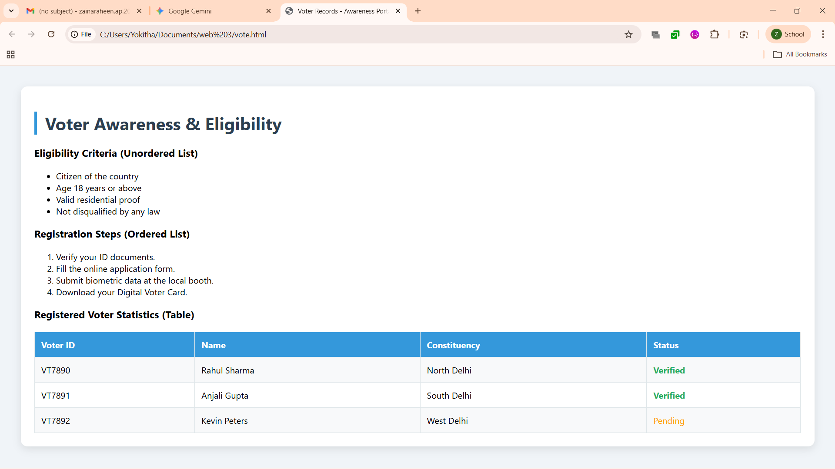

PROGRAM 2:
CODE:
<!DOCTYPE html>
<html>
<head>
<title>Voting Awareness Portal - Home</title>
</head>
<frameset rows="15%, 85%" border="1">
<frame src="header.html" name="header" scrolling="no">
<frameset cols="20%, 80%">
<frame src="nav.html" name="navigation">
<frame src="home_content.html" name="main_content">
</frameset>
</frameset>
</html>
OUTPUT:
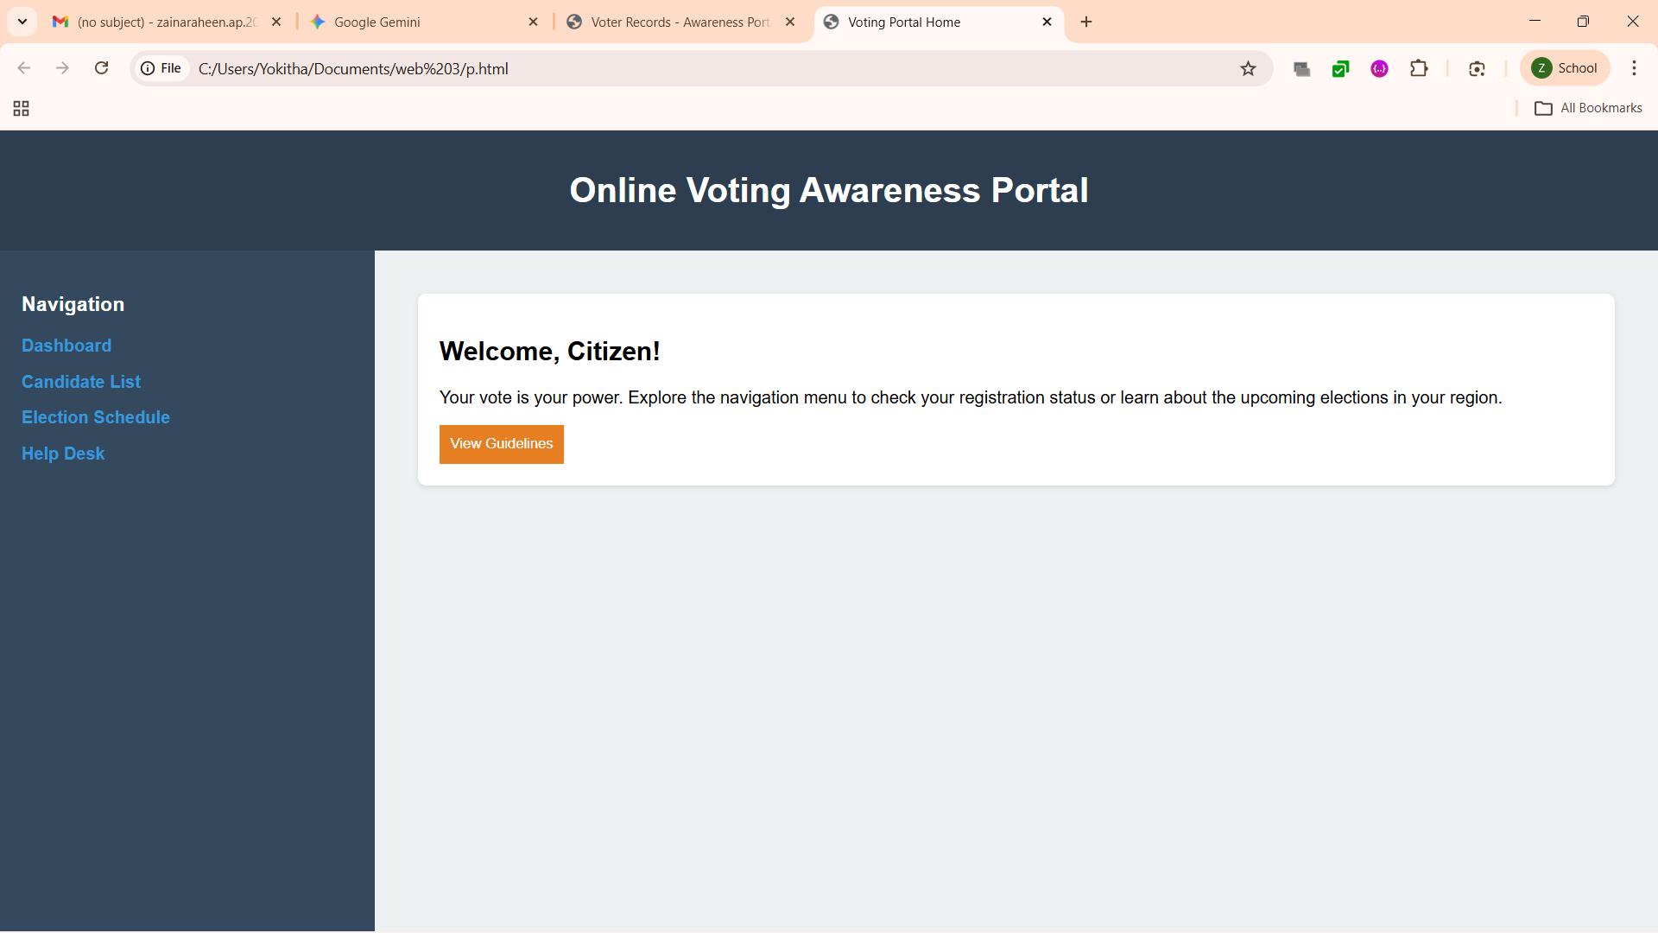

PROGRAM 3:
CODE:
<!DOCTYPE html>
<html>
<head>
<title>Candidate Profiles</title>
<style>
body { text-align: center; font-family: Arial; background: #ecf0f1; }
.links a { padding: 10px 20px; background: #2980b9; color: white; text-decoration: none; border-radius: 4px; margin: 10px; display: inline-block;}
</style>
</head>
<body>
<h1>Know Your Candidates</h1>
<div class="links">
<a href="profile1.html" target="profile_view">View Candidate A</a>
<a href="profile2.html" target="profile_view">View Candidate B</a>
</div>
<br>
<iframe name="profile_view" width="70%" height="400px" style="background: white; border: 2px solid #2980b9;">
<p>Click a candidate to view their profile and image.</p>
</iframe>
</body>
</html>
OUTPUT:
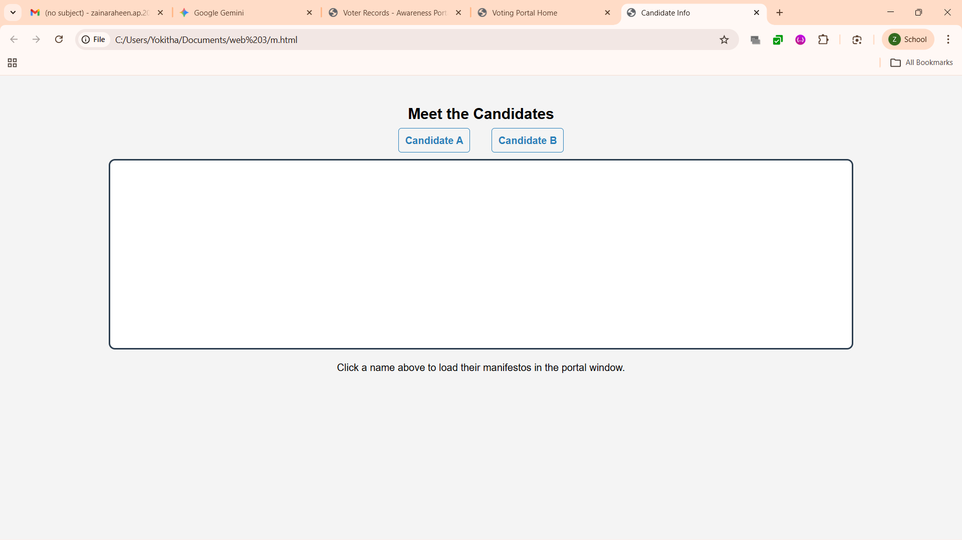

PROGRAM 4:
CODE:
<!DOCTYPE html>
<html>
<head>
<title>New Voter Registration</title>
<style>
body { font-family: sans-serif; display: flex; justify-content: center; background: #34495e; color: white; }
form { background: #2c3e50; padding: 40px; border-radius: 10px; width: 400px; box-shadow: 0 0 20px rgba(0,0,0,0.5); }
input, select, textarea { width: 100%; padding: 10px; margin: 10px 0; border-radius: 5px; border: none; }
.btn-row { display: flex; gap: 10px; }
input[type="submit"] { background: #27ae60; color: white; cursor: pointer; }
input[type="reset"] { background: #c0392b; color: white; cursor: pointer; }
</style>
</head>
<body>
<form action="submit_success.html" method="POST">
<h2>Voter Registration Form</h2>
<label>Full Name:</label>
<input type="text" name="voter_name" placeholder="Enter full name" required>

<label>Email Address:</label>
<input type="email" name="voter_email" placeholder="email@example.com" required>

<label>District/Branch:</label>
<select name="district" required>
<option value="District 1">North Region</option>
<option value="District 2">South Region</option>
<option value="District 3">East Region</option>
<option value="District 4">West Region</option>
</select>

<label>Gender:</label><br>
<input type="radio" name="gender" value="Male" style="width: auto;"> Male
<input type="radio" name="gender" value="Female" style="width: auto;"> Female<br>

<label>Permanent Address:</label>
<textarea name="address" rows="3" placeholder="Enter your full residential address" required></textarea>

<div class="btn-row">
<input type="submit" value="Register Now">
<input type="reset" value="Clear Form">
</div>
</form>
</body>
</html>
OUTPUT:
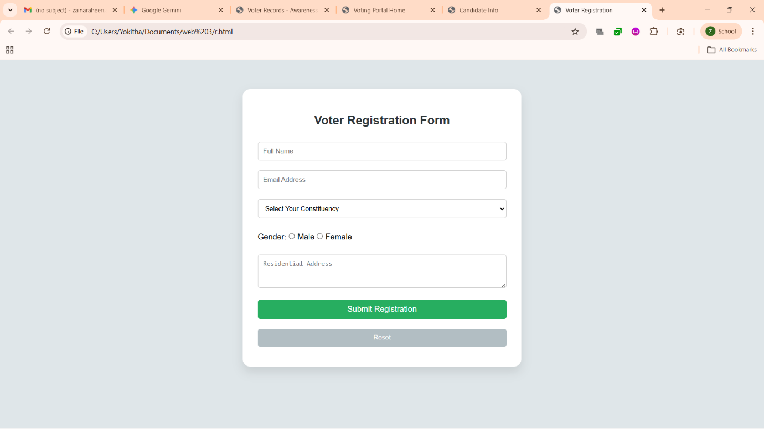

PROGRAM 5:
CODE:
<!DOCTYPE html>
<html>
<head>
<title>Interactive Constituency Map</title>
<style>
body { text-align: center; font-family: sans-serif; background: #f9f9f9; }
img { border: 5px solid #bdc3c7; border-radius: 10px; }
</style>
</head>
<body>
<h1>Regional Awareness Map</h1>
<p>Click on a region to view specific voting rules for that constituency.</p>

<img src="map.png" usemap="#voter_map" width="800" height="400" alt="Constituency Map">

<map name="voter_map">
<area shape="rect" coords="50,50,250,200" href="info_north.html" alt="North Region" target="info_frame">
<area shape="circle" coords="400,200,80" href="info_central.html" alt="Central Region" target="info_frame">
</map>

<br><br>
<iframe name="info_frame" width="80%" height="150px" style="border: 2px dashed #95a5a6;">
Click a region on the map to see details.
</iframe>
</body>
</html>

OUTPUT:
